1. Right click database, then select connect:

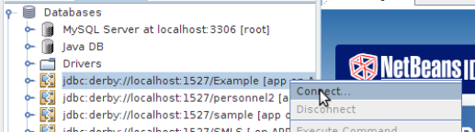

2.Right click database, then select Execute Command:

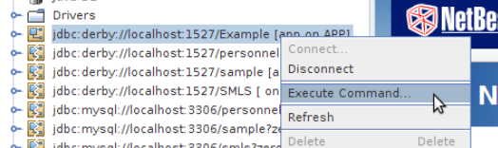

3.Type SQL code in the main window, and click the icon in the red square as show to Run SQL:

